- Steps for Students to Share Information
  - Self Service Share My Information
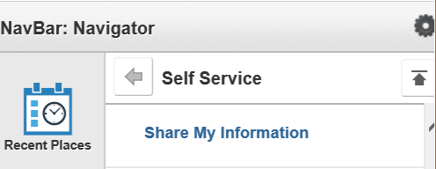
  - Security Share My Information
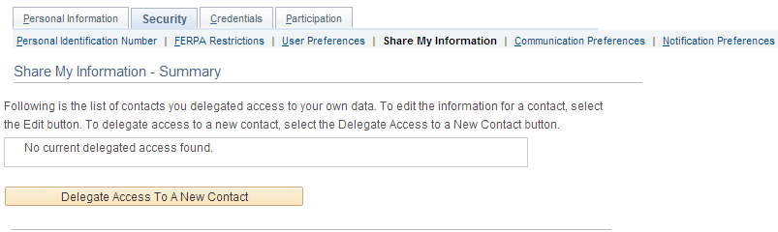
  - Accept Terms and Conditions
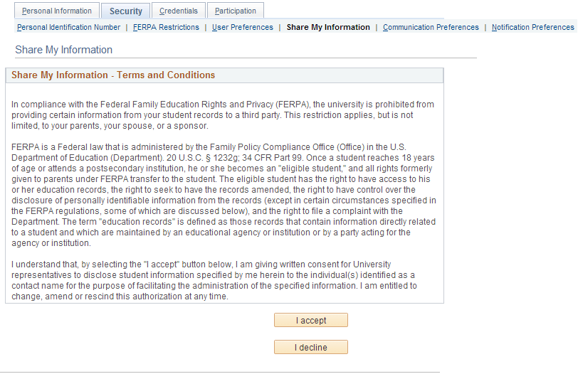
  - Confirmation E-mail
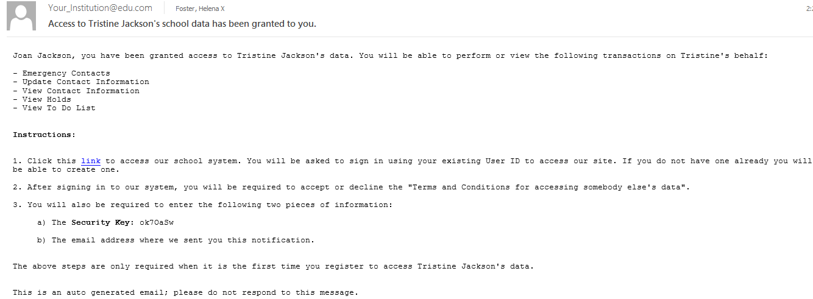
  - Student’s view of shared information page
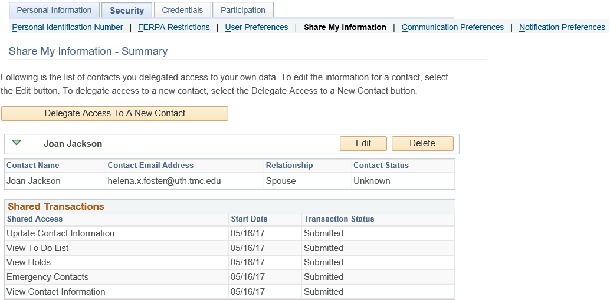
- Staff’s View of Shared Information (CC Delegated Access Preview Shared Information)
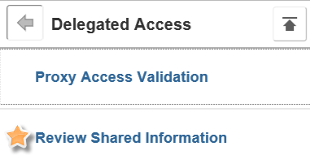
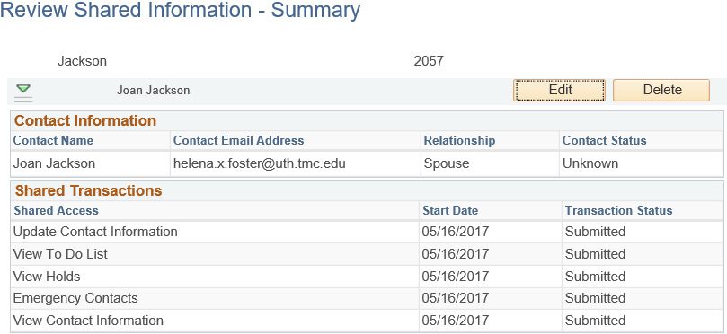
- Transaction Code Setup (Set Up SACR System Administration Utilities Delegated Access Delegation Transaction Setup)
